**Join queries**

**Inner join:**

SELECT book.Book_id, user.User_name

FROM book

INNER JOIN user ON book.User_id = user.User_id;

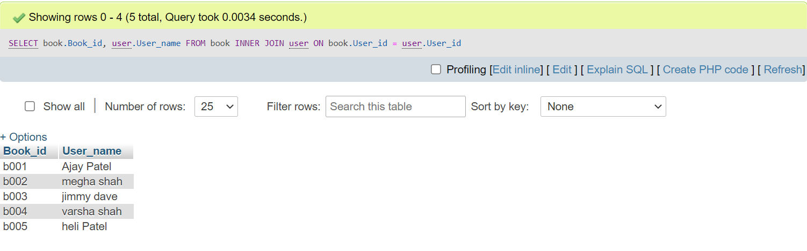

**Outer Join:**

**-->It is further divided into Three types:-**

**1)Left Join**

**2)Right Join**

**3)FULL OUTER JOIN**

1. **Left Join**

SELECT user.User_name,user.User_id,bill.PaymentAmount,bill.Payment_type

FROM user

LEFT JOIN bill ON user.User_id = bill.User_id;

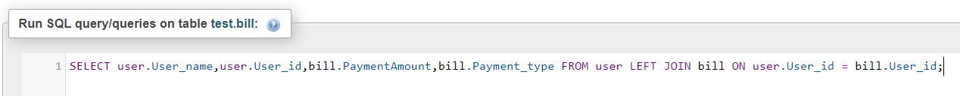

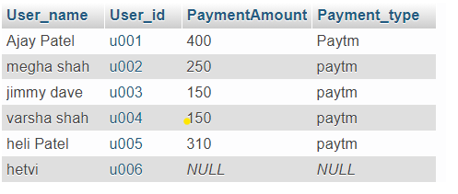

**2) Right Join**

SELECT user.User_name,user.User_id,book.Book_id,book.Book_name

FROM user RIGHT JOIN book ON user.User_id = book.User_id;



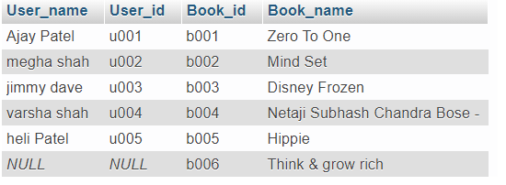

**3) FULL OUTER JOIN**

SELECT user.User_name,user.User_id,bill.Bill_id,bill.PaymentAmount,bill.Payment_type FROM user LEFT JOIN bill ON user.User_id = bill.User_id

UNION ALL

SELECT user.User_name,user.User_id,bill.Bill_id,bill.PaymentAmount,bill.Payment_type FROM user RIGHT JOIN bill ON user.User_id = bill.User_id

WHERE user.User_id IS NULL

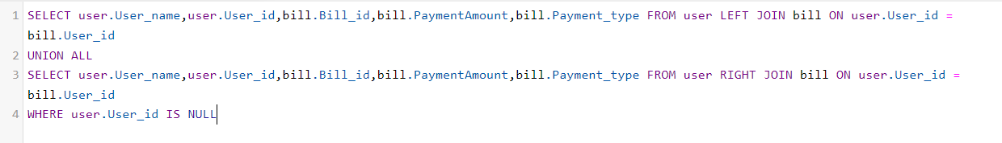

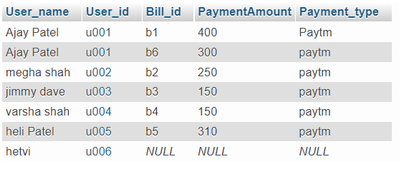

**Self join:**

SELECT b1.Book_id,b1.Bill_id,b1.User_id

FROM bill b1,bill b2

WHERE b1.Book_id=b2.Book_id

AND b1.Bill_id<>b2.Bill_id;

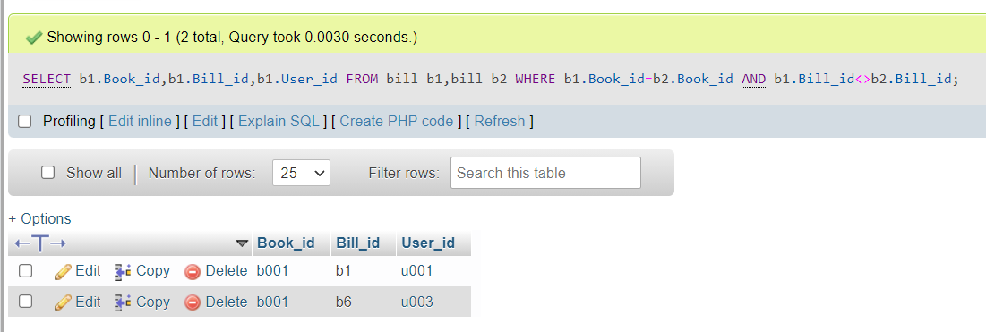

**Natural Join:**

SELECT available_stock.Book_name,book.Price

FROM book

NATURAL JOIN available_stock

WHERE available_stock.AvailabilityStatus='yes';

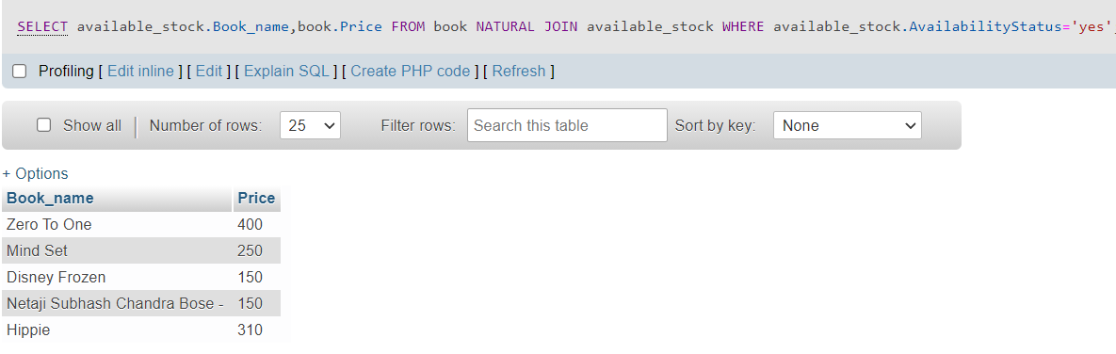

**SUB QUERIES**

**1**. SELECT * FROM bill WHERE Bill_id IN

(SELECT Bill_id FROM bill

WHERE PaymentAmount > 200) ;

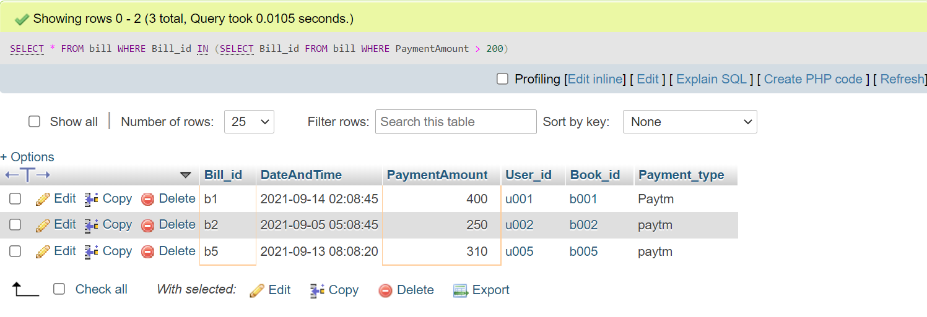

Triggers:--

→ create table logs

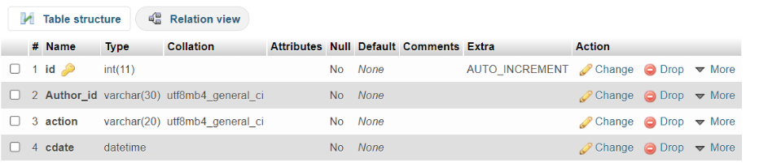

→ CREATE TRIGGER ‘insertLog’

AFTER INSERT

ON `author`

FOR EACH ROW INSERT INTO logs

VALUES(null,NEW.Author_id,’Inserted’,NOW());

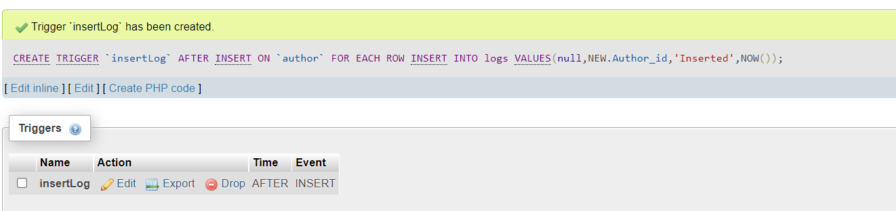

→Now, 1 row added in author table

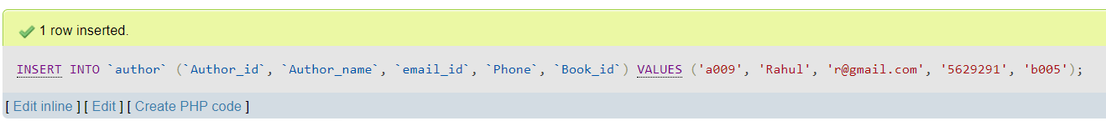

→ ss of logs table



→ CREATE TRIGGER ‘deleteLog’

BEFORE DELETE ON `author`

FOR EACH ROW INSERT INTO logs

VALUES(null,OLD.Author_id,’Deleted’,NOW());



→ now, we have deleted 1 row from author table

→ ss of final logs table

